K900
X86 Fanless Industrial Computer
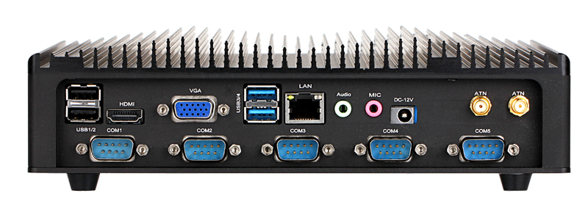 |  | Key Features  - Design for Industrial Automation M2M application  - Wide operating temperature range of -10°C~+60°C  - Aluminum Chassis with fanless design  - Support 6-36V Wide Voltage Input
System Parameters
Processor&Chipset | - •Onboard Intel® J1900 Four Cores, 2.0GHz, 2M Cache ,NM70 Chipset  - •Onboard Intel® N100 Four Cores, 3.4GHz, 6M Cache ,Intel® UHD Graphics  - •Onboard Intel® i3,i5,i7, 4th~14th Generation
Memory | 1 x DDR3 /DDR4 SO-DIMM socket, 2GB/4GB/8GB/16GB
Storage | 1 x 2.5" SATA 500GB/1TB/2TB  1 x Msata 16GB/32GB/64GB/128GB/256GB
Cooling System | Fanless design
BIOS | AMI 16MB DPI Flash
Watchdog Timer | 255 level, 0~255 sec
LAN | 1 x Realtek RT8111E, 10/100/1000M, Support PXE, Wake on Lan
Audio | Realtek ACL662 Audio controller, Line-out, Mic-in.
Expansion Port | 2 x MINI PCI-E full slot, 1 x SIM
OS | Linux/ Win dows XP/7/8/10/11
Expansion Function
GPIO | Optional
3G/4G | Optional
WIFI/BT | Optional(802.11 a/b/g/n, Bluetooth 4.0)
RS422/485 | Optional
IO Interface
COM | 2 x COM(Default RS232, 10x RS232 maximum)
RS422/485 | Optional (1x RS485/422)
VGA | 1x VGA with definition up to 1920x1200@60Hz, DB15 interface
HD MI | 1x HDMI, with definition up to 1920x1200@60Hz
USB | 3 x USB2.0+1 x USB3.0
LAN | 1 x RJ45, 10/100/1000M(2RJ45 Optional)
Audio | Line-out, Mic-in
LPT | Optional
ATN | 2 x Antenna port
GPIO |   Optional
Power Supply
Power Supply | 12V DC Power Input
Power Comsuption | <60W
Wide Voltage | Optional (DC 6~36V Wide Voltage, IPTS )
Environments
Operating Temp | -10℃~50℃
Storage Temp | -30℃~70℃
Relative Humidity | 5~95%@10℃ (Non-condensing)
Vibration | 5~500Hz,1.5G,0.15mm peak value
Shake | 1.5 Grms, IEC 60068-2-64, 5 ~ 500 Hz, 1 hr/axis
Shock | 10 Grems, IEC 60068-2-64, Half sine wave,for 11 ms
EMC | CE/FCC Class A
Enclosure
Housing Material | All Aluminum Chassis with fanless design
Dimensions | 209 mm (W) x 179 mm (D) x 56.5 mm (H)
Net Weight | 2KG

